MSU Extension’s Six-Step Community Change Model

Step 2: Bring People Together

Step 2 Worksheet: Bring People Together
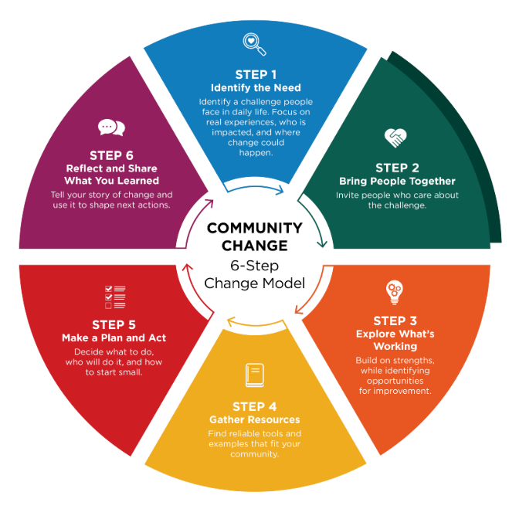
Community Champions often act as connectors who help engage overlooked voices, bridge sectors, and energize others to turn ideas into action.

Real change happens when people come together, talk openly, and listen to those who are closest to the issue. When you create space for honest conversation, about what is working and what could be better, people feel invited to take part. When people feel heard and their ideas matter, they are likely to take ownership. That sense of ownership is what helps change last.

Think about who should be involved

Start by identifying who needs to be part of the conversation from the beginning. Consider people who:
- Care about the issue
- Directly impacted by the issue
- Make decisions or influence how things are done
- Understand how the setting works day to day
- Have valuable insights but may be overlooked
- Are trusted, motivated, and able to help move ideas forward

For example, local law enforcement officers may understand safety issues that affect food pantry outreach. Youth often offer perspectives adults may miss. Some of these individuals may become community champions.
Having people from different sectors—such as schools, nonprofits, health care, businesses, or local government—can help the group share resources and ideas. Using a shared approach, such as the Collective Impact Framework, can strengthen the group’s results.

Questions to help guide your outreach

Ask:
- Who cares about or is impacted by this issue and wants to see improvement?
- Who can help make decisions or influence next steps?
- Who has the time, skills, or resources to support this work?
- Who has strong relationships with the people affected?
- Who could help turn ideas into action?
- Who are the philanthropic partners that might support the work?

Identify someone to guide the process

It is helpful to have a dedicated point person who can guide the group and keep the work moving forward. This individual could be someone from your organization or a partner willing to assist. While partners can provide valuable support and guidance, the organization or group closest to the issue should take the lead in decision-making, driving action, and sustaining the changes over time.

Step 2 Worksheet: Bring People Together

Identify who should be part of the conversation from the beginning. Community Champions often act as connectors who engage overlooked voices and build trust across sectors.
Folks may come from different sectors across the community, or they may all come from a single organization. Public sectors to consider are:

- Agriculture
- Childcare
- Commercial marketing/local business
- Community design/planning
- Community members (including youth or elders)
- Education (school, after-school programs)
- Food industry (producers, distributors, and processors)
- Food retailers (grocery, corner store, farmers market)
- Government (local, county, tribal, state)
- Health care (clinics, hospitals, educators)
- Local Food Policy Councils or networks
- Media
- Neighborhood groups
- Public health
- Public safety
- Social/human services
- Transportation

Who should be involved?

Sector/Group | Specific Individuals or Organizations | Champion(s) to Engage | How We’ll Invite/Engage

Champion support in step 2

Choose all that apply:
- Community Champion identifies missing voices
- Community Champion makes introductions and warm invites
- Community Champion helps build norms that welcome everyone
- Community Champion co-facilitates early conversations

Reflection

- Who are the people impacted by the issue and how will their voice be heard?
- Do you have the right people at the table? Are any key people or sectors missing from your list who can help make decisions and influence next steps?

About MSU Extension’s Community Change Model
This Guide and Worksheet is part of a larger Six-Step Community Change Model Toolkit that assists community champions in supporting communities to make thoughtful, lasting improvements that help people choose nourishing foods and stay active. Six simple steps guide desired change efforts by bringing people together, taking action, and sharing what was learned along the way.
See MSU Extension’s Community Change Hub for curated resources and topic-specific guidance that support change efforts related to championing school wellness, food access, early childhood health, and active communities.

